Problem 1: Write a C++ program to create and display a singly linked list. (Traversing)

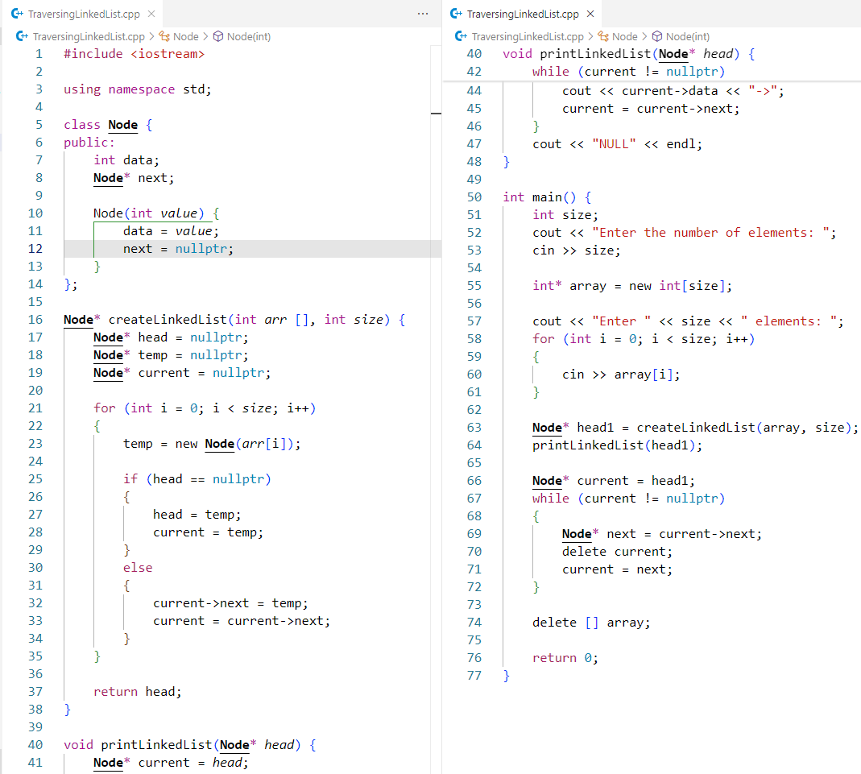
Code:

Output:
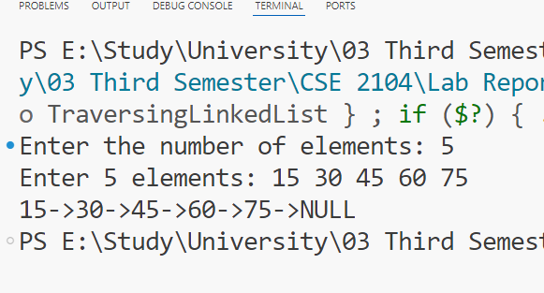

Problem 2: Write a C++ program to create and search for an element in a singly linked list.

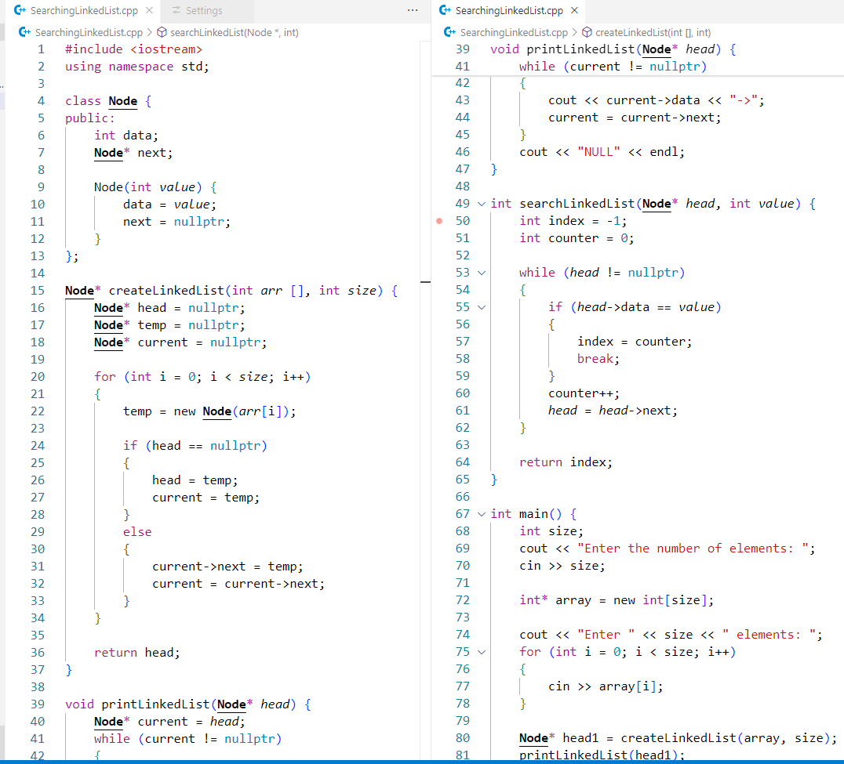
Code:

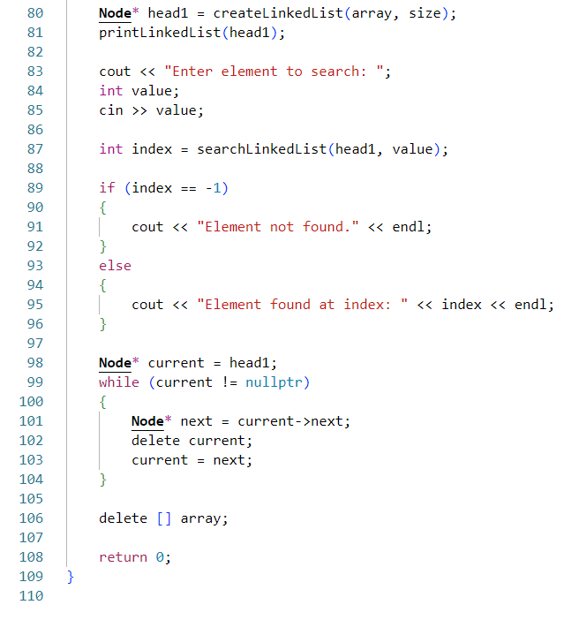
Output:
